LESSON PLAN

School : SMP
Subject : English
Class / Semester : VIII / II
Skill : Reading
Standard competence :
11. Understanding the meaning of a simple essay in form of recount and narrative to interact with the close students’ environment.
Basic competence :
11.3 Responding the meaning and the generic structure of a simple essay accurately in form of recount and narrative which related to the students’ environment.
Indicator :
Reading aloud several narrative texts
Identifying the meaning of several narrative texts
Text type : Narrative
Meeting : 1
Time allotment : 2 x 40 minutes

- Objectives:
At the end of the lesson, students are able to:
- Read narrative text with proper intonation, stress and pronunciation.
- Find certain meaning in the narrative text.

- Learning materials:
- A storybook of the gingerbread man and a text of the gingerbread man
- Pictures of glossary

- Technique:
Storytelling

- Learning activities:
Pre-activities (10 minutes)
- Greeting
- Checking students attendance
- Checking students prior knowledge toward the story

Main-activities (60 minutes)
- Teacher shows the title of the book to the children. Then make them to pronounce it.
- Children are introduced some unfamiliar vocabularies that often appear in the story.
- Teacher reads the story using some dramatization to show a character’s expression, physique or emotion. In telling the story, teacher locates the storybook in the location that is visible by the children and moves around so that everyone could see.
- Children are engaged to participate actively in the storytelling activity through singing or clapping or dancing.
- Teacher shows pictures in the book to the children, so that they comprehend the story.
Post-activities
- Teacher asks several questions about some actions of the characters in the story. (This activity is used to make children predict the story from the pictures).
- Children respond to the story.
- Students are given some exercises to know their comprehension reading comprehension toward the story.

- Learning sources:
Parsons, G. (2012). The gingerbread man. Oxford: Oxford University Press.

- Learning evaluation:
Reading
- Technique : Test
- Form : Written
- Instrument :
Reading Comprehension
The Gingerbread Man
(Adapted from Oxford, 2012)

- What do they say? Write the words.

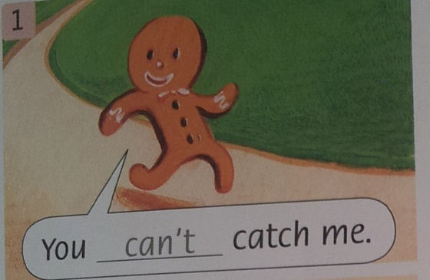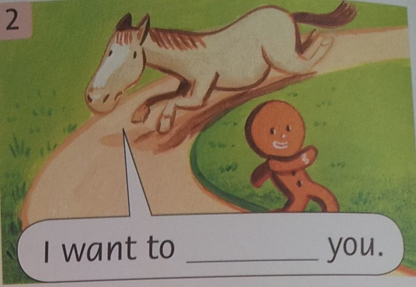

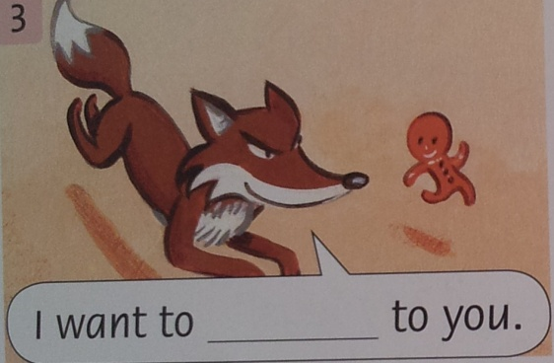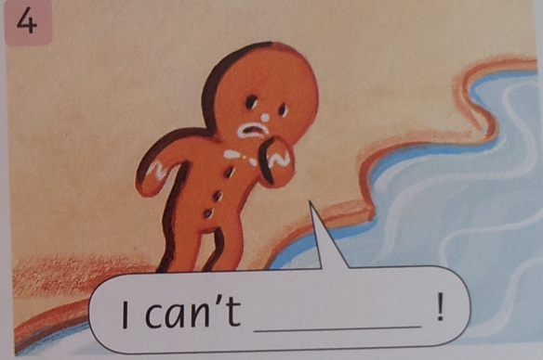

- Put the words in the correct order.
- The-kitchen-woman’s-in-old-the
The old woman’s in the kitchen.
- and little runs The gingerbread runs man
………………………………………………………………………………
- to with I be you want friends
………………………………………………………………………………
- river fox out across and The twins jumps the
………………………………………………………………………………

- Make sentences about the story.
1. | The gingerbread man has two eyes, … | a cow and a horse.
2. | The old woman opens the oven door …. | ‘I can help you.’
3. | He runs away from … | a nose, and a mouth.
4. | He sees a river … | sits on the fox’s tail.
5. | The fox says, … | but he can’t swim.
6. | So the gingerbread man … | and he jumps out.

LESSON PLAN

School : SMP
Subject : English
Class / Semester : VIII / II
Skill : Reading
Standard competence :
11. Understanding the meaning of a simple essay in form of recount and narrative to interact with the close students’ environment.
Basic competence :
11.3 Responding the meaning and the generic structure of a simple essay accurately in form of recount and narrative which related to the students’ environment.
Indicator :
Reading aloud several narrative texts
Identifying the meaning of several narrative texts
Text type : Narrative
Meeting : 2
Time allotment : 2 x 40 minutes

- Objectives:
At the end of the lesson, students are able to:
- Read narrative text with proper intonation, stress and pronunciation.
- Find certain meaning in the narrative text.

- Learning materials:
- A bigbook of the owl babies
- Pictures of vocabularies

- Technique:
Storytelling

- Learning activities:
Pre-activities (10 minutes)
- Greeting
- Checking students attendance
- Checking students prior knowledge toward the story

Main-activities (60 minutes)
- Show the picture or the book cover to the students and read the title of the story.
- Ask the students to describe it with the guidance questions from storyteller.
a). Where is the three baby owls? (in a hole of a tree with their owl mother) Is the owl babies happy? (No) How’s feeling. Do you think? (e.g. sad, lonely, worried, lost) Why? (three owl babies really missed their mommy) Listen to the students’ ideas, and extend their ideas as appropriate.
- Show the pictures as part of a story. Then, ask the students to predict what they think happens in the story before and after the moment in the picture.
- Ask questions to stimulate their ideas, e.g. How many owls who sat on the branch? Did the owl mother leave her babies? Did the owl babies miss their mother? Where was the setting of the story? What were the babies thought about their mother? What were the owl babies done while waiting for their mother? How many branches for the owl babies?
- Once the students have elaborated their ideas about the story, say Let’s listen and find out! Read or tell the story once.
- Get the students to compare what happens in the story with their predictions.
- Ask them what they think is the moral of the story (e.g. we have to be honor to our mother or be patient or we must love our family like sarah, percy and bill)
- Students’ show their respond toward the story.
- They do some exercises to know their reading comprehension toward the story.

Post-activities
- Teacher asks several questions about some actions of the characters in the story. (This activity is used to make children predict the story from the pictures).
- Children respond to the story.
- Students are given some exercises to know their comprehension reading comprehension toward the story.

- Learning sources:
Waddell, M. (1992). Owl babies. London: Walker Books, Ltd.

- Learning evaluation:
Reading
- Technique : Test
- Form : Written
- Instrument :
Reading Comprehension
The Owl Babies

- Write the words and find the name of somebody in the story.
2
1
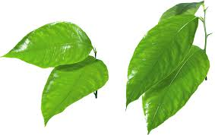
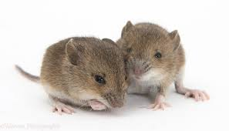
 | (1)M | I | C | E
(2)
 |  | (3)
 | (4)
 |  |  |  | (5)
(6)

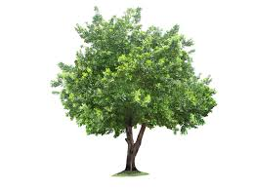
5
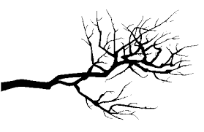
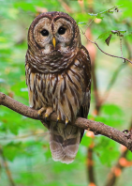

4

3
6
6

- Make sentences about the story. Then write them in the correct order.
1. | The three baby owls lived .... | their mother had gone.
2. | The hole had .... | and wish their owl mother would come.
3. | When baby owls woke up .... | then the babies danced and bounced up and down on their branch.
4. | The baby owls had to be brave .... | in a hole of a tree.
5. | The baby owls closed their eyes .... | twigs, leaves and owl feathers in it.
6. | The owl mother came .... | stay alone in the dark night.

- The three baby owls lived in a hole of a tree.
- _____________________________________________________________________
- _____________________________________________________________________
- _____________________________________________________________________
- ____________________________________________________________________
- _____________________________________________________________________

LESSON PLAN

School : SMP
Subject : English
Class / Semester : VIII / II
Skill : Reading
Standard competence :
11. Understanding the meaning of a simple essay in form of recount and narrative to interact with the close students’ environment.
Basic competence :
11.3 Responding the meaning and the generic structure of a simple essay accurately in form of recount and narrative which related to the students’ environment.
Indicator :
Reading aloud several narrative texts
Identifying the meaning of several narrative texts
Text type : Narrative
Meeting : 3
Time allotment : 2 x 40 minutes

- Objectives:
At the end of the lesson, students are able to:
- Read narrative text with proper intonation, stress and pronunciation.
- Find certain meaning in the narrative text.

- Learning materials:
- A storybook of little red riding hood
- A copy of this story for children
- A set of strips of little red riding hood story

- Technique:
Storytelling

- Learning activities:
Pre-activities (10 minutes)
- Greeting
- Checking students attendance
- Checking students prior knowledge toward the story

Main-activities (60 minutes)
- Divide the class into groups of four.
- Give a set of sentences (in jumbled order) or strips of card to each group.
- Ask the students whether they know the plot of the story or not. Listen to their ideas
- Students arrange the sentences in the order of the story on their desks.
- Check the answer by inviting individual students from different groups to take turns to read the sentences in order.
- Explain and demonstrate that the students should not show their sentences. The child who has the sentence Once upon a time … should begin reading the story clearly to the rest of the group. The child who has the second sentence should then read that sentence, and so on until the group has read the whole story.
- They then reshuffle the strips of card, redistribute the sentences and repeat the procedure. The aim is to take turns to read the story as a group as seamlessly and fluidly as possible.
- Teacher read the story of ‘Little Red Riding Hood’

Post-activities
- Ask the students to predict the moral lesson in the story.
- Students show their respond toward the story.
- They do some exercises to know their reading comprehension

- Learning sources:
Lamoreaux, M. (2011). Little red riding hood. Oxford: Oxford University Press.
Phillips, D., Burwood, S., & Dunford, H. (1999). Projects with young learners. Oxford: Oxford University Press.

- Learning evaluation:
Reading
- Technique : Test
- Form : Written
- Instrument : a strips of cards

Reading Comprehension
Little Red Riding Hood
(Adapted from Oxford, 2011)

- Who is speaking? Write the name for 1-4.
For number 5, what does Grandma say? Write one sentence.
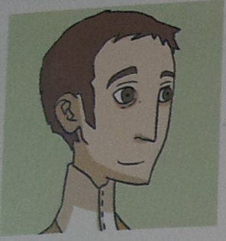 | 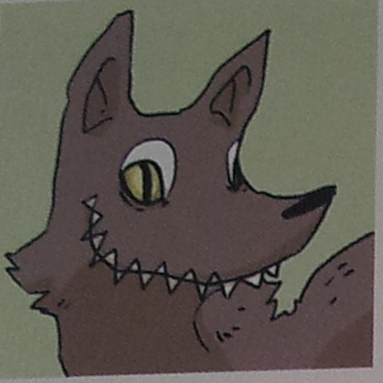 | 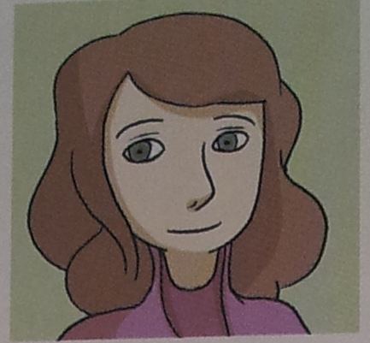
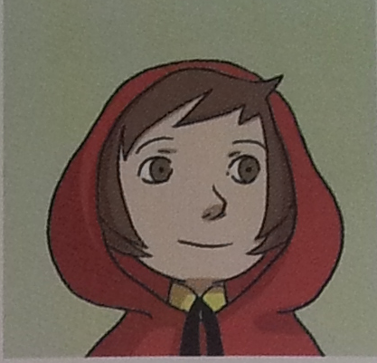 |  | 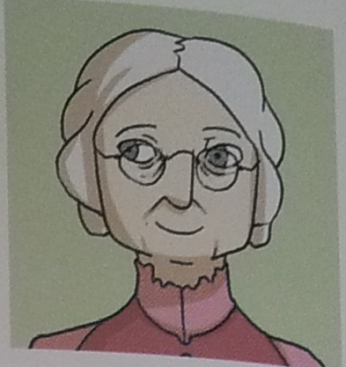

1. | ‘Little Red Riding Hood, your grandma is ill’ | Mother
2. | ‘Perhaps I can eat this little girl and her grandma.’
3. | ‘Grandma, you’ve got very big eyes today!’
4. | ‘What are you doing in Grandma’s bed?’
5. |  | Grandma

- Match, then complete the sentences with the past tense.
Stay | run | See | Tell | go | say
Told | ran | Stayed | Said | went | Saw

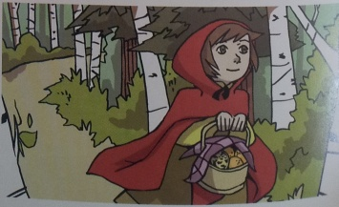
Little Red Riding Hood and her father (1) went home to their little white house. Little Red Riding Hood (2) _____________ to her mother and (3) ____________ her everything. ‘But it’s all right now!’ she (4) ___________. After that, Little Red Riding Hood always (5) ____________ on the road. And she never (6) __________ a wolf again.
- Make sentences about the story. Then write them in the correct order.
1. | Little Red Riding Hood ran to her mother and …. | ate Little Red Riding Hood.
2. | The wolf jumped out of the bed and … | ran into the forest.
3. | Little Red Riding Hood’s father took his knife and … | told her everything.
4. | Little Red Riding Hood took the basket and …. | killed the wolf.

- Little Red Riding Hood took the basket and ran into the forest.
- ……………………………………………………………………………….
- ……………………………………………………………………………….
- ……………………………………………………………………………….

LESSON PLAN

School : SMP
Subject : English
Class / Semester : VIII / II
Skill : Reading
Standard competence :
11. Understanding the meaning of a simple essay in form of recount and narrative to interact with the close students’ environment.
Basic competence :
11.3 Responding the meaning and the generic structure of a simple essay accurately in form of recount and narrative which related to the students’ environment.
Indicator :
Reading aloud several narrative texts
Identifying the meaning of several narrative texts
Text type : Narrative
Meeting : 4
Time allotment : 2 x 40 minutes

- Objectives:
At the end of the lesson, students are able to:
- Read narrative text with proper intonation, stress and pronunciation.
- Find certain meaning in the narrative text.

- Learning materials:
- A storybook of Rapunzel
- A copy of this story for children

Rapunzel

Many years ago, there lived a man with his pretty wife. They had a beautiful little house, but they did not have child. They always missed for their own child.
Near their house was a big mansion with a cabbage garden. It belonged to a witch. One day, the man’s wife fell seriously ill. She wanted some cabbages from the witch’s garden.
Then, the man decided to take the cabbages without permission from the witch. The witch found that the man wanted to steal the cabbage in her garden. When the man saw the witch approached him. He confused. He told his reason to the witch. The witch permitted him to take the fresh cabbage if he agreed to give his first child to her. He agreed with the request and returned home with cabbages and a heavy heart.
After two years, this couple has a beautiful baby-girl. As the husband’s promise before to the witch, he has to give his baby to the witch. After the witch knew that the baby had born, she came to the couple’s house and took the baby from the mother’s arm to her castle. The couple felt sad, but they did not do anything. Then, she was named ‘Rapunzel’.
The witch did not want to lose her. hid her in a tall tower in a forest. The tower It only had one small window at the top. No one ever visited her except the witch. On reaching the tower she would call out, “Rapunzel, Rapunzel, Let down your hair.” After that, the witch climbed the tower using Rapunzel’s golden hair. Rapunzel felt isolated in the tower. She did not see everyone except the witch for a long time.
One day, when Rapunzel sang a melodious song, a prince who rode a horse passed the tower and heard the song. The prince had never heard such a sweet voice in his life. He was fascinated. He wanted to meet the singer in the tower.
In the evening, the prince came and shouted, “Rapunzel, Rapunzel! Let down your hair.” Rapunzel threw her hair and the prince climbed over the tower. Seeing a young man, Rapunzel was surprised. The prince also amazed with Rapunzel’s beauty. They felt in love in the first sight. The prince said that he would come back as early as possible.
The witch did not agree with the relationship. She cut Rapunzel’s hair. The witch then brought Rapunzel to a desert far from Rapunzel’s tower so that the man could not find her anymore.
The man tried to find Rapunzel. He cannot be separated from rapunzel. He could not life without rapunzel. He roamed the jungle with his horse to find Rapunzel.
Finally, he heard the same melodious voice that he could not forget. He cried out, “Rapunzel, Rapunzel!!” Rapunzel ran towards him. She then cried. Finally, the prince took Rapunzel to his big palace. They were married and lived happily thereafter.

- Technique:
Storytelling

- Learning activities:
Pre-activities (10 minutes)
- Greeting
- Checking students attendance
- Checking students prior knowledge toward the story

Main-activities (60 minutes)
- Divide the class into pairs.
- Give a piece of text to the each pair.
- Ask the students whether they know the plot of the story or not. Listen to their ideas
- They are asked to find the difficult words that appears in the story.
- Check the answer by inviting individual students from different groups to take turns to read the sentences in order.
- Teacher read the story of ‘Little Red Riding Hood’

Post-activities
- Ask the students to predict the moral lesson in the story.
- Students show their respond toward the story.
- They do some exercises to know their reading comprehension

- Learning sources:
O’kif, A. (2013). Rapunzel. Oxford: Oxford University Press.

- Learning evaluation:
Reading
- Technique : Test
- Form : Written
- Instrument :

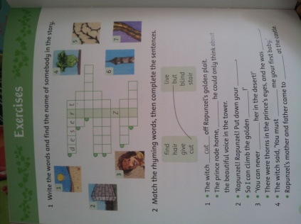
3. Make sentences about the story.
Then write them in the correct order.
- The woman wanted to eat a lettuce.
- The witch came _______________________________________________________
- Rapunzel cried ________________________________________________________
- Rapunzel sang _______________________________________________________
- The prince fell _______________________________________________________
- The man took ________________________________________________________
for the prince every day.
into the thorns.
a fresh green lettuce for his wife.
to eat a lettuce.
to take the man’s daughter.
because the prince was so thin and tired.

LESSON PLAN

School : SMP
Subject : English
Class / Semester : VIII / II
Skill : Reading
Standard competence :
11. Understanding the meaning of a simple essay in form of recount and narrative to interact with the close students’ environment.
Basic competence :
11.3 Responding the meaning and the generic structure of a simple essay accurately in form of recount and narrative which related to the students’ environment.
Indicator :
Reading aloud several narrative texts
Identifying the meaning of several narrative texts
Text type : Narrative
Meeting : 5
Time allotment : 2 x 40 minutes

- Objectives:
At the end of the lesson, students are able to:
- Read narrative text with proper intonation, stress and pronunciation.
- Find certain meaning in the narrative text.

- Learning materials:
- Simple past
For example:
- He caught a big golden fish in his trap
- They got married

- Text of Lake Toba
Lake Toba
Once upon a time in a village of North Sumatra, lived a diligent farmer. He did some gardening and fishing for his daily life. One day, when he went fishing, he caught a big golden fish in his trap.
After he back home, he found that fish turned into a beautiful lady. He felt in love with her and proposed her to be his wife. She said yes with one condition that was the man had to promise not to tell a soul about the secret that she was once a fish, otherwise if he did that there would be a huge disaster. The man made the deal and they got married, then had a daughter.
Few years later, the daughter was so hungry and she ate his father lunch. He found out and got furious, and shouted “You are daughter of a fish”.
The daughter ran home and asked her about that, then her mother felt sad that her husband had broke his promise. After that, she prayed. Soon there was a big earthquake followed by nonstop pouring rain. Finally, the whole area got flooded and became Lake Toba.

- Technique:
Storytelling

- Learning activities:

Pre-activities (10 minutes)
- Greeting
- Checking students attendance
- Checking students prior knowledge toward the story

Main-activities (60 minutes)
- Ask the students in their own language if they know the meaning of the story title. And then, let them to share their ideas of the words. (Accept any of their suggestions, repeating each word clearly).
- Students are asked to read a piece of text about lake toba
- Invite the students to note down the vocabularies in the form of a diagram or word map so that they have a record of what they know about the subject and what they are going to hear later in the story.
- Get the class to visualize the vocabulary and to understand the basic vocabulary by using TPR (total physical response).
- The students respond the vocabularies in a physical way by carrying out the instructions.
Example:
He did some gardening and fishing in his daily life.
- Start to tell the story using visualization (a huge pictures displayed in front of the classroom) and put up the pictures of the characters on the board as they
are mentioned.
- At the end, the representatives of each group were asked to tell the storytelling using puppet in front of the classroom.

Post-activities
- Ask the students to predict the moral lesson in the story.
- Students show their respond toward the story.
- They do some exercises to know their reading comprehension

- Learning sources:
- Bachtiar, B. (2005). Let’s Talk. Bandung: Pakar Raya.
- Text/worksheet is taken from http://bromocorra.wordpress.com/legend-of-lake-toba/
- Dictionarry
- Related pictures below

Pictures

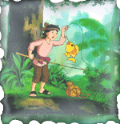
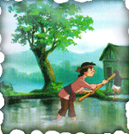


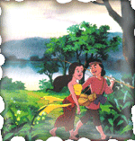

- Learning evaluation:
Reading
- Technique : Test
- Form : Written
- Instrument :
Lake Toba
Once upon a time in a village of North Sumatra, lived a diligent farmer. He did some gardening and fishing for his daily life. One day, when he ……… (1) fishing, he ……… (2) a big golden fish in his trap.
After he back home, he ……… (3) that fish turned into a beautiful lady. He ……… (4) in love with her and proposed her to be his wife. She ……… (5) yes with one condition, that was the man had to promise not to tell a soul about the secret that she was once a fish, otherwise if he did that there would be a huge disaster. The man made the deal and they got married, then had a daughter.
Few years later, the daughter ……… (6) so hungry and she ……… (7) his father lunch. He ……… (8) out and ……… (9) furious, and shouted “You are daughter of a fish”.
The daughter ran home and asked her about that, then her mother felt sad that her husband had ……… (10) his promise. After that, she prayed. Soon there was a big earthquake followed by nonstop pouring rain. Finally, the whole area got flooded and became Lake Toba.
Answer key:
1. Went 6. Was
2. Caught 7. Ate
3. Saw 8. Found
4. Felt 9. Got
5. Said 10. Broke

LESSON PLAN

School : SMP
Subject : English
Class / Semester : VIII / II
Skill : Writing
Standard competence :
12. Expressing the meaning of a simple essay in form of recount and narrative to interact with the close students’ environment.
Basic competence :
12.2 Expressing the meaning and the generic structure of a simple essay accurately in form of recount and narrative which related to the students’ environment.
Indicator :
Write a simple essay accurately in form of recount and narrative using appropriate generic structure.
Text type : Narrative
Meeting : 6
Time allotment : 2 x 40 minutes

- Objectives:
At the end of the lesson, students are able to:
- Write a simple narrative text using appropriate linguistic features and generic structure.

- Learning materials:
- A text of Lake Toba

- Technique:
Storytelling

- Learning activities:
Pre-activities (10 minutes)
- Greeting
- Checking students attendance
- Checking students prior knowledge toward the story

Main-activities (60 minutes)
- Put the students into groups.
- Ask the class to list the types of stories that they like and write these on the board, for example, fairy tales, fables, mystery, romance, folktales. Ask the students why they like these types of stories and write up some of the words beside each type of story.
- Take one of the stories.
- Explain the structure of a story using a story, for example ‘Lake Toba’, including social function and linguistic features. Ask the students how many ‘events’ there are in the story and perhaps write them on the board (including: beginning, middle, and end).
- Ask some questions (what kind of story it is? when does the story take place? where does the story take place? who is in the story? what are the names of the characters in the story?) orally to the students.
- Explain to the students that a good story often has a structure like this and when they make up their stories in the next lesson they will need to keep them quite simple with just a few exciting events.

Post-activities
- Teacher asked students difficulties during the learning process
- Teacher and students reviewed the lesson together.

- Learning sources:
- Text/worksheet is taken from http://bromocorra.wordpress.com/legend-of-lake-toba/
- Dictionarry

- Learning evaluation
One day Little Red Riding Hood’s mother asked her to take some apples to her grandmother who lived far away in the forest.
It was a lovely day as Little Red Riding Hood walked through the forest to her grandmother’s house.
Meanwhile the big bad wolf was hungry. He crept quietly into grandmother’s house and ate her up in one big bite.
Then the big bad wolf put on grandmother’s clothes. A little later Little Red Riding Hood arrived at her grandmother’s house.
She thought her grandmother looked different:’What great big eyes you have Grandmother,’ she said.
‘All the better to see you with my dear,’ the wolf replied.
‘What great big ears you have Grandmother,’ she said.
‘All the better to hear you with,’ the wolf replied.
‘What great big teeth you have Grandmother,’ she said.
‘All the better to eat you with,’ the wolf replied and jumped towards Little Red Riding Hood.
Suddenly the woodcutter arrived and killed the big bad wolf.
Little Red Riding Hood was saved!
Finally the woodcutter cut open the wolf’s tummy and grand mother jumped out alive!

LESSON PLAN

School : SMP
Subject : English
Class / Semester : VIII / II
Skill : Writing
Meeting : 7-10
Standard competence :
12. Expressing the meaning of a simple essay in form of recount and narrative to interact with the close students’ environment.
Basic competence :
12.2 Expressing the meaning and the generic structure of a simple essay accurately in form of recount and narrative which related to the students’ environment.
Indicator :
Write a simple essay accurately in form of recount and narrative using appropriate generic structure.
Text type : Narrative
Time allotment : 2 x 40 minutes

- Objectives:
At the end of the lesson, students are able to:
- Write a simple narrative text using appropriate linguistic features and generic structure.

- Learning materials:

- Technique:
Storytelling

- Learning activities:
Pre-activities (10 minutes)
- Greeting
- Checking students attendance
- Checking students prior knowledge toward the story

Main-activities (60 minutes)
Meeting | Activities | Time allotment
7th | Teacher shows again the story of lake toba.  Students are instructed to find the characters, setting, plot (baca buku derewianka dalam menulis narrative)  Based on the data that they has got. Students make mind map of their story using their own characters in Bahasa Indonesia. | 60’
8th | Students elaborate their mind map into a story in Bahasa Indonesia (briefly max. 3 paragraphs) | 60’
9th | Students translate their story in english.  Then teacher tries to check their writing individually  Submitted | 60’
10th | After the students’ writing have been checked by teacher. Students look again their text and revise their writing. | 60’

Post-activities
- Teacher asked students difficulties during the learning process
- Teacher and students reviewed the lesson together.

- Learning sources:
Derewianka, B. (1990). Exploring how texts work. Sydney: Primary English Teaching Association.

- Learning evaluation:
A narrative writing rubric that is adopted from Knapp and Callaghan (1989, pp. 72-73 in Emilia, 2011, pp. 149-150)

