DOSEN PEMBINA | : | RATIH INAYAH, S.PD., M.PD. / TIM DOSEN
QUIZ | : | CLOSE BOOK / OPEN BOOK / QUIZ  WRITING IN PROFESSIONAL CONTEXT QUIZ  NOVEMBER 23 2020

CHOOSE THE BEST ANSWER TO EACH QUESTION.
- STRUCTURE
- Laura ... any of her assignment yet. She has to learn to manage her time well.
- is doing
- won't do
- hasn't done
- does not do

- I am sure the students… the exam well right now because we have learnt this hard.
- is
- are passed
- will be going to do
- are doiing
- I like the product because ...
- it is cheap and complicated
- it is portable and reasonable
- it is reasonable and excessive
- it is easy to operate and expensive

- If we want to go forward, to have a better life, and to earn more, we have to be dare to think out of the box. ‘To think out of the box’ could means .... .
- to make samething dangerous
- to try something which surely endangers us
- to decide something without second thought
- to do something you really want to do despite its risk

- Although Julian .... with us only for five years, he had shown us his full commitment, dedication Engineering of Industry.
- was
- will be
- is being
- has been

- The COVID-19 pandemic ... educational systems worldwide, leading to the near-total closures of schools, universities and colleges.
- has affected
- have affected
- affected
- will affect

- Accounting ... one of prospective major. Companies need this field so much.
- is
- has
- will
- was

- “Shelly has passed the interview in the company.” The sentence means ... .
The sentence above means ....
- she is going to work in the company then
- she wanted to be interviewed
- she failed the interview
- she migh have to find another job

- Galileo Galilei .... telescope and Christopher Columbus .... America in 1492. They are both included to the most popular inventors in the the world.
- invented - discoverd
- invent - discoverd
- inventing - discover
- inventing - discovering

- To attract the HRD attention, we have to ... in the part of the body of an application letter.
- respond the job description posted by the company and explain our qualities suited to the position.
- introduce ourselves in lenght and compliment the greatness of the company
- prove that we are the only candidate eligible for the position
- thank the HRD for calling us for the interview

- What is not the reason that Akmal and Rajev attend the university?
- It is located in convenient area
- It is far away from the city center.
- It is one of the best university in Indonesia.
- It has complete facilities and qualified lecturers.

- Which of the following sentences is in present perfect tense?
- Did Farkhan complete the assignment?
- Will Farkhan complete the assignment?
- Had Farkhan completed the assignment?
- Has Farkhan completed the assignment yet?
- What is the best description of this device?
- It is the most expensive and wanted tool this time.
- It is one of the most needed and condamned apparatus this year.
- It becomes the most popular and sophisticated game console for kids.
- This is one of the most important and highly needed device for learning right now.

- Nikson asks a fortune teller about his future. Here is what she told him:
“You ______ a lot of money if you work hard.” I guess he need not to go there someday.
- will earn
- will earns
- has earned
- Are going to earning

- To talk about a general fact, we use ... .
- The present tense
- The past future
- The future simple
- The present continuous

- Someone who writes a letter for employment purposes is called an... .
- applicant
- application
- employee
- employer

- The phrase ‘Dear Sir/Madam,’ in an application letter is called ... .
- Closure
- closing
- Salutation
- Inside address
- Body of the letter

- Jessica is really excited about her new online business. I think she‟s really going ... .
- to take the plunge
- success breeds success
- get a break
- nothing ventured, nothing gained

- David has been running his business for over a year now, but he is doing really well. Sometimes it can take quite a long time ... .
- success breeds success
- to get off the ground
- to think outside the box
- to get away

- Alex is a really creative guy, with very unusual ideas. He certainly ... .
- thinks outside the box
- makes a go of it
- take the plunge
- to make someone down

- The accounting records ... the auditor when I came.
- are being audited
- were being audited
- had been audited
- is auditing

- 'I am looking forward to hearing from you'. This sentence is found in which part of an application letter?
- Salutation
- Closing
- Signature
- Body

- The company offered us childcare vouchers. The passive voice of the sentence is ... . You can choose more than one answers
- Childcare vouchers were offered to us
- We are offered childcare vouchers by the company
- We were offered childcare vouchers by the company
- We were being offered childcare vouchers by the company

- Sarah Connor welcomed the new employees. The passive form of the sentence is ... .
- The new employees were welcomed by Sarah Connor
- The new employees are welcomed by Sarah Connor
- The new employees will be welcomed by Sarah Connor
- The new employees be welcomed by Sarah Connor

- The ideas of corporate social responsibility ...by that company few years ago.
- were introduced
- was introduced
- were being introduced
- is introduce

- Kami sudah mengenal Dion selama lebih dari 10 tahun.
The correct translation of the sentence is ... .
- We known Dion for more than 10 years.
- We had known Dion for more than 10 years.
- We have known Dion for more than 10 years.
- We have been knowing Dion for more than 10 years.

- Someone is not using his mask even though he is coughing a lot. In the moment of corona virus issue, you may express these, except ... .
- I am displeased that he is so ignorant of other people
- I am not keen on his being so hesitant of using mask
- I can’t stand being nearby him for this is so dangerous
- I would prefer to use my mask rather than give it to the sick

- What is NOT the right description of this picture?
- She has a beautiful face and a nice smile.
- She looks beautiful and humble
- She has a prefect face and shiny black hair
- She is pretty and she has a pointed nose
Source: nisya+sabian&tbm=isch&ved

- Which is not true about this for young people in positive ways?
- Concentration boosters
- Entertainment in leisure time
- A place to express creativities
- Educational sources and creativeness

- ... is the term that includes everything about working for a company, such as the people, the work, the company, and the characteristics of the work and company.
- Employ
- Employer
- Employee
- Employment

- READING
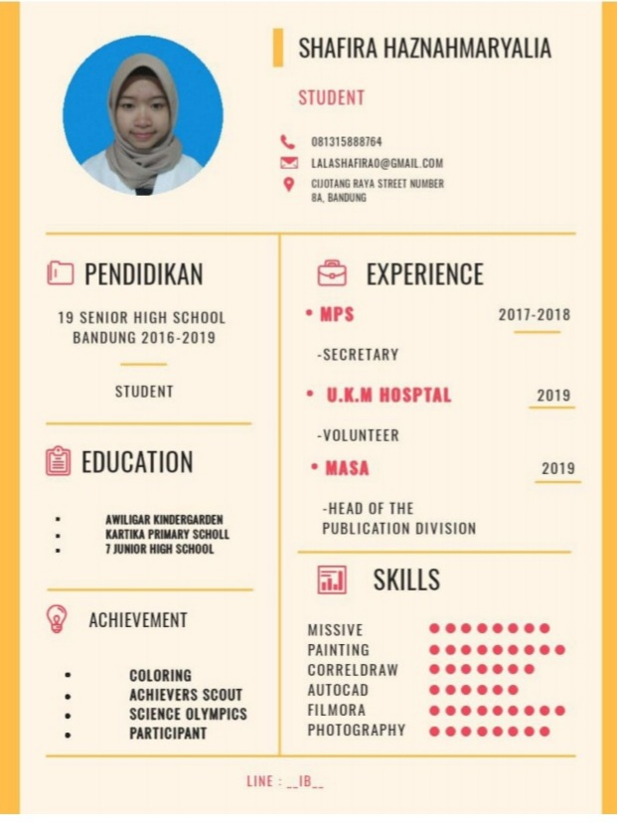
Text 1

Source: Cover Letter Assignment/Shafira

- What is a resume according to the picture?
- It is a document created by an applicant to boast their their background, skills, and accomplishments.
- It is a document used and created by a person to present their background, skills, and accomplishments.
- is a document created and modified by a person to present their personalities, skills, and expectation.
- is a document used and created by a person to show up their skills and accomplishments.

- Why do you think an employer is interested to the owner of the resume?
- She is creative and initiative.
- She has a good career and achivement.
- She has good backgrounds and aptitudes.
- She has some organizational experiences and high school graduate

Text 2

June 03, 2020
Personnel Manager
Kettle, Kettle & Co
Bandung

Dear Sir/Madam,
I am writing regarding your advertisement in Pikiran Rakyat Daily Newspaper on September 13, 2012. I have given careful consideration to the job description and believe that I have the necessary qualifications and personal attributes to take up the position.
Although I lack practical experience in the field of advertising, my past work experiences have shown that I’m able to learn quickly from experienced staff. In my previous job as a teacher, it was necessary to understand the difficulties of student and at the same time, to motivate them to strive for the best in their academic works.
I have enclosed my resume for your consideration with copies of my certificates and qualification.
I would relish the opportunity to work as part of an enthusiastic office staff. I look forward to the opportunity for an interview.

Your sincerely,

Asep

- Asep’s experience as a teacher was ...
  - to practice advertising experiences.
  - to motivate students in their academic works.
  - to consider students’ certificate qualifications.
  - to qualify her personal attributes to the position.

- From the text, we know that the applicant ...
  - established an advertising company.
  - wanted to teach advertising class.
  - considered all students’ works.
  - thought she could learn fast.

- The purpose of the text is ... .
- to apply for a position by detailing the Personal Manager
- to apply for a job by providing details to show the applicant’s qualities
- to give information about the writer’s quality to attract the owner of the company
- to testify that the applicant is eligible to the position due to his excellent background

- . Which is not true about the applicant?
- He used to be a teacher.
- He excelled in practical experience in the field of advertising,
- He attachedhis resume, certificates and other qualifications in his application letter
- He quite understood the students’ difficulty and motivated them to give their best in academic works.
Text 3

- What is possibly the author’s purpose to write the text?
- To overview Ronaldo’s early life.
- To give Ronaldo’s description in detail.
- To tell the readers about Christiano’s biography.
- To describe Cristiano Ronaldo physical description.

- Which of the following information is not true about Cristioano Ronaldo according to the text?
- He has 3 siblings.
- He is a fast runner and a handsome man.
- He celebrates his birthday on the fifth February.
- He plays for Portugal and comes from Real Madrid.

- From the text we know that people likely idolize him because
- he is a very tall and a great man.
- he comes from western country.
- he is good looking and tall.
- he is a handsome man and a great football player

- What is his favorite color?
- Red
- Blue
- White
- Black
Text 4
When the typewriter was first invented, its keys were arranged alphabetically. This made the keys easy to find. However, this arrangement also caused the bars of the machine to jam, or get stuck.
To solve this problem, a new letter arrangement was introduced by Christopher Latham Scholes in 1872. His system, the standard keyboard system, is still used on typewriters today. He arranged the letters in such a way that as many bars as possible hit the inked ribbon from opposite directions. This resulted in far less jamming than had occurred with the alphabetical models.
(quoted from: Longman Introductory Course, 2014)

- “ ... its keys were arranged alphabetically.” The word ‘it’ refers to ... .
- the alphabet
- the typewriter
- the invention
- the inventor

- In Schole's system, the order of the letters ...
(A) is in the alphabetical order.
(B) enables more bars to hit the ribbon from opposite direction.
(C) had caused the bars of the machine to jam.
(D) was the same as original typewriter.

- We know from the second paragraph that ...
  - the Scholes' system is still used now.
  - the Scholes' system arranged the letters alphabetically.
  - the original arrangement of the letters was alphabetical.
  - the arrangement of the letters in the Scholes' system is not better than the original one.

- Improvemnt to the original system of the typewriter was made by Scholes in ...
- the arrangement of the letters.
- the bars that hit the ribbon.
- the ribbon that carries the ink.
- the standard keyboard system.

- He arranged the letters in such a way. The passive form of the sentence is ... .
- The letters was arranged by him in such a way
- The letters are arranged by him in such a way
- The letters were arranged by him in such a way
- The letter had been arranged by him in such a way

LISTENING AND WRITING(ESSAY)
Listen to and watch this video. Then, answer 5 questions below.
Beingsuccessful in the interview (https://www.youtube.com/watch?v=kayOhGRcNt4)
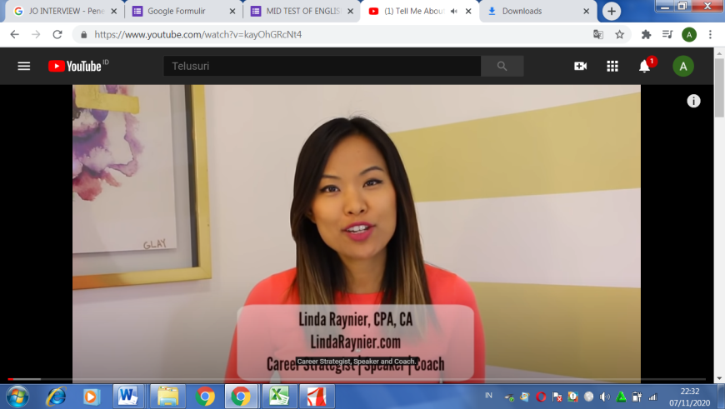

- If the interviewer says 'tell me about yourself', what should you do?
- In rule no. 2, the presenter said that we have to tell about 'the story of the interviewee professionally' in three ways. They are ... .
- If you are asked about 'your previous job', mention 3 important things to tell the interviewer.
- What is the second tip about?
- After watching the video, what can you learn? (Free answer)

------------------SELAMAT BEKERJA-----------------

