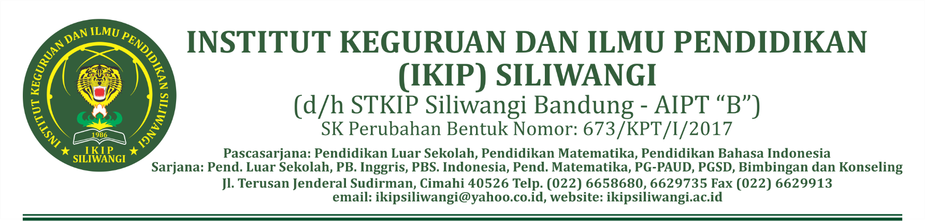

SOAL UJIAN AKHIR SEMESTER (UAS) GANJIL 2020/2021
PRODI PENDIDIKAN BAHASA INGGRIS

MATA KULIAH : ENGLISH FOR TOURISM
KODE : 4922622545
DOSEN : Silpia Rahayu, S.Pd.,M.Hum.
ANGKATAN : Regular/2018
WAKTU : 90 MENIT
SIFAT UJIAN : CLOSED BOOK/GADGET

Answer the following questions. Please always check your spelling & grammar.

- What is tourism based on your opinion?
- Match one word from column A and one word from column B to make a​ typical combination (for example, travel + agent). Give each combination​ of words a definition. ​
- The following terms are very closely related to airport reservation. What do they mean?

aisle | boarding area | cockpit | gate
aisle seat | boarding pass | emergency exit | lavatory
baggage claim area | carry-on luggage | flight attendant | life jacket

- Which hotels exist in your city? Mention the name of those hotels; the type of guest stay on those hotel; facilities and services that are offered
- How to make a hotel reservation using traveloka?
- Mention the steps of hotel check-in process!
- If you are as a front desk clerk, what are the techniques for dealing with complaints?
- What are the contents of an itinerary?
- How the steps to check out with the front desk?
- Create a dialog about making flight reservation using the situation below:
You are going to go to Bali with your family next week from 25-30 December 2020. Book a flight along with the hotel.

***Good luck***

Mengetahui,

Ketua Program Studi | Koordinator KBK | Dosen Pengampu
Yana, S.Pd, M.Hum | Yanuarti Apsari,M.Pd. | Silpia Rahayu,S.Pd.,M.Hum.

